# Asura

* Asuras असुर are described as power-seeking clans related to the more benevolent Devas (also known as Suras) in Hinduism that are in constant battle with the devas.
* In early Vedic literature, the good Asuras are called Adityas and are led by Varuna, while the malevolent ones are called Danavas and are led by Vritra.
  + **Aditya** refers to the offspring of Aditi, the goddess representing the infinity. The name Aditya, in the singular, is taken to refer to the sun god Surya. Generally, Adityas are twelve in number and consists of Vivasvan, Aryaman, Tvashta, Savitr, Bhaga, Dhata, Mitra, Varuna, Amsa, Pushan, Indra and Vishnu
* **Dānavas** were a race descending from Danu, a daughter of the progenitor god Daksha. Danu is connected with the waters of the heavens and is likely associated with the formless primordial waters that existed before creation. She is identified as the mother of Vritra, the demonic serpent slain by Indra. In later Hinduism, she becomes the daughter of the god Daksha and his spouse Panchajani, and the consort of the sage Kashyapa. As a word for "rain" or "liquid", dānu is compared to Avestan dānu, "river"
* It is said that there are 100 Dānava sons of Danu. The Dānavas were not considered to be universally evil, as individual Dānava may be aligned with good or evil.
* The Devas exiled the Dānavas from heaven during the Satya Yuga. After the exile, the Dānavas took refuge in the Vindhya Mountains or the Vindhya Range
  + Satya Yuga सत्ययुग is known as the age of truth, when humanity is governed by gods, and every manifestation or work is close to the purest ideal and humanity will allow intrinsic goodness to rule supreme. It is sometimes referred to as the "Golden Age". The god Dharma (depicted in the form of a bull), which symbolizes morality, stood on all four legs during this period. The legs of Dharma reduce by one in each yuga that follows.
  + The Vindhya Range (also known as Vindhyachal) (pronounced [ʋɪnd̪ʱjə]) is a complex, discontinuous chain of mountain ridges, hill ranges, highlands and plateau escarpments in west-central India. Roughly parallel to the Narmada River in Madhya Pradesh
* The Asura realm/domain (also known as the Jealous God domain) is one of the realms, in which one can be reborn as a result of experiencing the fruits of wholesome karma while engaging in unwholesome karma. Generally, the desire realm recognize as consisting of five realms and the realm of asura tends to be included among the deva realm. The domain of the Asuras is not regarded as separate from that of the Nāgas
  + Nāga नाग is a divine or semi-divine race of half-human half-serpent beings that can occasionally take human form.
* In Buddhism, the leaders of the asuras are called asurendra (阿修羅王; lit. "Asura-lord"). There are several of these, as the Asuras are broken into different tribes or factions. In Pali texts, names that are found include Vepacitti, Rāhu (Verocana), Pahārāda, Sambara, Bali, Sucitti, and Namucī (Mara).
* Headcanon: Despite the Deva-Asura war, Brahma is teaming up with Danu to get the Twilight Core

# Boss3 Danu, Mother of the Asura (Danava), Goddess of the Waters

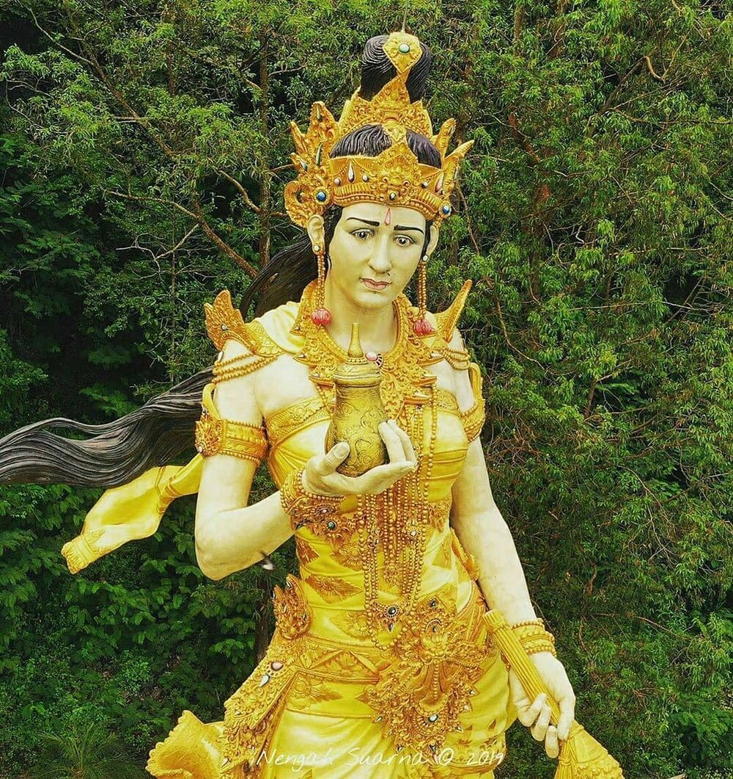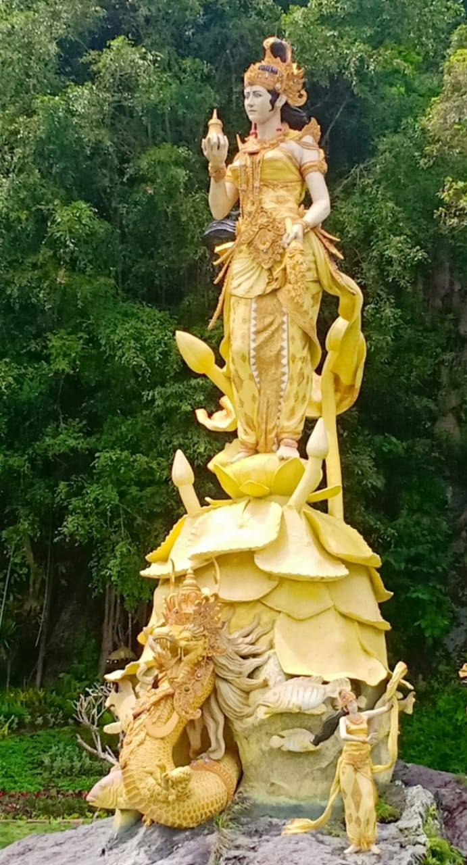

*Dewi Danu (Balinese)*

# Deva/Devi

* Deva /देव means "heavenly, divine, anything of excellence", and is also one of the terms for a deity in Hinduism. Deva is a masculine term; the feminine equivalent is Devi.
* The Deva domain (also known as the God domain or Blissful State) is the domain of bliss. The disadvantage of this domain is that things are so very comfortable there, that these beings completely neglect to work towards enlightenment.
* Some devas represent the forces of nature and some represent moral, each symbolizing the epitome of a specialized knowledge, creative energy, exalted and magical powers
  + Brahma the deity of creation
  + Vishnu the deity of preservation
  + Shiva the deity of destruction and time; associated with fertility and regeneration
  + Ganesha the deity of new beginnings, wisdom, and luck
  + Hanuman the deity associateded to courage, reverence and strength/avatar of Shiva
  + Kartikeya the deity of victory and war
  + Vishwakarma the deity of architecture
  + Dhanvantari the deity of doctors and Ayurveda/avatar of Vishnu
  + Dyaus the deity of the aether (or sky)
  + Vayu the deity of air, wind and breath
  + Varuna the deity of water and rain
  + Agni the deity of fire
  + Yama the deity of death and justice
  + Samudra the deity of the seas/form of Varuna
  + Kubera the deity of opulence and wealth
  + Kamadeva the deity of love
  + Indra the king of deities and deity of weather, storms and sky
  + Ashwini Kumara the deity of health and medicine
  + Surya the deity of the sun, light and day
  + Chandra the deity of the moon and night
  + Mangala the deity of Mars and Aggression
  + Budha the deity of Mercury and Nature
  + Brihaspati the deity of Jupiter and teacher of the Devas
  + Shani the deity of Saturn and deeds (karma)

## Boss 4 Lakshmi/Saraswati/Parvati Tridevi

* In the Shaktidharma denomination the feminine Tridevi goddesses are given the eminent roles of Creator (Mahasaraswati), Preserver (Mahalakshmi), and Destroyer (Mahakali),
* **Saraswati** is the goddess of learning, arts, and cultural fulfillment, as well as the consort of Brahma, the creator. She is cosmic intelligence, cosmic consciousness, and cosmic knowledge.
  + Saraswati, is a Sanskrit fusion word of saras (सरस्) meaning "pooling water", but also sometimes translated as "speech"; and vati (वती) meaning "she who possesses" The word evolves in its meaning from "waters that purify", to "that which purifies", to "*vach* (speech) that purifies", to "knowledge that purifies"
  + Saraswati is known by many names in ancient Hindu literature. Some examples of synonyms for Saraswati include Brahmani, Brahmi, Bharadi, Vani, Vachi, Varnesvari, Kavijihvagravasini, Vidyadatri, Veenavadini, Pustakdharini, Veenapani, Hansavahini and Vagdevi.
  + The goddess Saraswati is often depicted as a beautiful woman dressed in pure white, often seated on a white lotus, which symbolizes light, knowledge and truth
  + The four hands hold items with symbolic meaning – a pustaka (book or script), a mālā (rosary, garland)
  + Avatar **Vidya** विद्या the formless concept of wisdom and knowledge in all of its aspects. Agni Vidyā or the science of fire is said to be the greatest discovery of the ancient Indians who gained direct experience of divine fire through continuous research, contemplation, observation and experimentation; their experience led them to discover ways of using this knowledge to heal and nurture the outer and the inner worlds.
* **Lakshmi** is the goddess of wealth, fertility, auspiciousness, light, and material and spiritual fulfillment, prosperity, glory, magnificence, joy, exaltation, and greatness, and spiritual fulfillment
  + Lakshmi is depicted in Indian art as an elegantly dressed, prosperity-showering golden-coloured woman standing or sitting in the padmasana position upon a **lotus throne**, while holding a lotus in her hand, symbolising fortune, self-knowledge, and spiritual liberation
  + Below, behind, or on the sides, Lakshmi is very often shown with one or two elephants, known as Gajalakshmi, and occasionally with an owl. Elephants symbolize work, activity, and strength, as well as water, rain and fertility for abundant prosperity. The owl signifies the patient striving to observe, see, and discover knowledge, particularly when surrounded by darkness. As a bird reputedly blinded by daylight, the owl also serves as a symbolic reminder to refrain from blindness and greed after knowledge and wealth have been acquired
  + Avatar **Gayatri** गायत्री is the personified form of the Gayatri Mantra, a popular hymn from Vedic texts.
* **Parvati** is the Hindu goddess of power, nourishment, harmony, devotion, and motherhood. She is a physical representation of Devi in her complete form
  + Parvati, the gentle aspect of Devi Shakti, is usually represented as fair, beautiful, and benevolent. She typically wears a red dress (often a sari), and may have a head-band
  + Hands may hold a trident, mirror, rosary, bell, dish, goad, sugarcane stalk, or flowers (such as a lotus)
  + The Puranas tell the tale of Sati's marriage to Shiva against her father Daksha's wishes. Daksha does not invite Shiva to his yagna. Sati comes on her own and immolates herself at the ceremony. This shocks Shiva, who isolates himself in the mountains. Sati is then reborn as Parvati, "she from the mountains"
  + Avatar **Mahakali** महाकाली is the Hindu Goddess of destruction and doomsday. Mahakali is fiercest of the Goddesses of universal power, time, life, death and both rebirth and liberation. She devours Kala (Time) and then resumes her own dark formlessness. She is also the consort of Mahakala, the god of consciousness, the basis of reality and existence. Mahakali in Sanskrit is etymologically the feminized variant of Mahakala or Great Time (which is interpreted also as Death), an epithet of the god Narasimha or Shiva in Hinduism.
* According to Lalitopakhyana of Brahmanda Mahapurana, Parvati, Lakshmi, and Saraswati are the three incarnations of Lalita
  + Phase + spell per devi +Final form Lalita?

# Other

* The desire realm कामधातु is one of the trailokya or three realms in Buddhist cosmology into which a being wandering in saṃsāra may be reborn. The other two are the form realmand the Formless Realm
* The six domains of the desire realm are also known as the "six paths of suffering", the "six planes", and the "six lower realms".